High School ESS Activity: Seismic Hazards

Performance Expectations:
(main) HS-ESS3-6: Use a computational representation to illustrate the relationships among Earth systems and how those relationships are being modified due to human activity.
(secondary) HS-ESS3-1: Construct an explanation based on evidence for how the availability of natural resources, occurrence of natural hazards, and changes in climate have influenced human activity.

Could also use this for middle school:
(main) MS-ESS3-2: Analyze and interpret data on natural hazards to forecast future catastrophic events and inform the development of technologies to mitigate their effects.
(secondary) MS-ESS2-2: Construct an explanation based on evidence for how geoscience processes have changed Earth’s surface at varying time and spatial scales.
(secondary) MS-ESS3-4: Construct an argument supported by evidence for how increases in human population and per-capita consumption of natural resources impact Earth’s systems.

a) Go to: http://www.iris.edu/seismon/
b) Click on “Earthquake browser”
c) Click on “Time Range” under the “Options” on the right and change the Earliest Available date to “1984-01-01” (hit “Apply”)
d) Set the “Max quakes” to a value that works well with your computer and internet connection (the more earthquakes you load, the longer it can take)
e) Zoom in to various regions to become familiar with the data set. Sometimes you have to hit “Apply” to load the new data. According to the color bar, if you are away from a plate boundary, what is the depth range of most earthquakes?
Less than 33 km

f) Under the “Go to: Region/Topic” bar, choose “Mystery under Romania”
g) Select “Open as 3D Viewer”
h) Rotate the 3D map of earthquakes. Roughly how deep are the deepest earthquakes here?
About 160 km

i) What do you think is the tectonic reason for the depth of these earthquakes?
This is a piece of ancient subducted ocean lithosphere

j) Using the map controls, zoom into the many earthquakes that have occurred in Oklahoma. There are now more earthquakes per month, on average, than there are in California.
k) Using the Time Range controls under “Options,” what do you notice about the time distribution of these earthquakes?
They are mostly recent. About half the earthquakes have occurred since the start of 2013.

l) Select “Open as 3D Viewer”
m) Rotate the 3D map of earthquakes. Roughly how deep are most of the earthquakes here?
About 5 km or less [Explain to students that when the earthquake is very shallow, the exact depth is often uncertain and the depth is set to 5.0 km. This can be seen by opening the earthquakes in the “Open as Table” option.]

n) What is the likely cause of these recent and shallow earthquakes?
Hydrologic fracturing.

o) Under the “Go to: Region/Topic” bar, choose “Japan Region”
p) Again, click on “Time Range” under the “Options” on the right and change the Earliest Available date to “1984-01-01” (hit “Apply”)
q) Under “Magnitude range” change the range to 4 to 10, and read the number of earthquakes in this range. (It is in the “Earthquake count” box, and it should read 42786 [the actual wording is “1000 of 42786 (1000 visible)” because the “Max quakes” will be set to 1000])
r) Do the same thing for the ranges 5-10, 6-10, 7-10, 8-10, 9-10. Record your numbers in Table 1 (I have already put in the value for the 4-10 range).
s) Take the log10 of these numbers and enter them into Table 1 (I have already done this for the 4-10 range). (Use 2 digits to the right of the decimal place, such as 3.27)
t) Plot these points on the graph in Figure 1 (I have already done this for the 4-10 range).
u) Draw a line through these points
v) Determine the slope through these points (you can measure it from your graph or use an online linear regression calculator such as: http://www.alcula.com/calculators/statistics/linear-regression/). What is it? (-0.94)

w) When large numbers of earthquakes are analyzed, this slope turns out to be remarkably close to -1. What does this slope mean in physical terms?
There are 10x fewer earthquakes at each successive magnitude value.

x) Do the same process for magnitude ranges 3-10 and 2-10. Note how these points would plot below the line. Explain why.
At some point earthquakes are too small to be consistently recorded, so the data are missing.

y) Press “Deselect Region” on the left side of the map
z) Make sure the Time Range is still “1984-01-01” and set the Magnitude Range to be 6-10 (hit “Apply”)
aa) Choose any region of the earth (your home, California, Australia, etc.), but make sure that (1) there are no earthquakes of Magnitude 6 or larger, and (2) there are still plenty of earthquakes.
bb) Using Table 2 and Figure 2, find the number of earthquakes at a few different magnitudes, and draw a line through the points. (Make sure that you pay attention to the answer in (s) and don’t use magnitudes that are too small.) What is the slope?
(Answers will vary)
cc) You are now going to estimate the likelihood of the recurrence of magnitude 6 earthquakes. Using a slope of -1, what is the log₁₀ value of a point on the line at a magnitude of 6? (this is likely a negative number)
(Answers will vary)

dd) Convert this log₁₀ value back into the actual number of magnitude 6 earthquakes per 30 years (this is likely a number less than 1). What is it?
This should be 10^{x}, where x was the answer in (cc)

ee) Convert the answer from (dd) into the number of years expected between magnitude 6 earthquakes. What is it?
This should be 30/(dd)

[NOTE: IF YOUR REGION DOES HAVE MAG 6 EARTHQUAKES, THEN YOU CAN DO THE SAME ACTIVITY INCLUDING MAG 6 EARTHQUAKES TO PREDICT A MAG 7 EARTHQUAKE.]

Table 1.: Seismicity of Japan
Magnitude Range (≥ to) | Number of Earthquakes | Log10 of # of Earthquakes
4 | 42786 | 4.63
5 | 5640 | 3.75
6 | 474 | 2.68
7 | 49 | 1.69
8 | 6 | 0.78
9 | 1 | 0

Figure 1.: Graph of frequency-magnitude relationship for Japan earthquakes

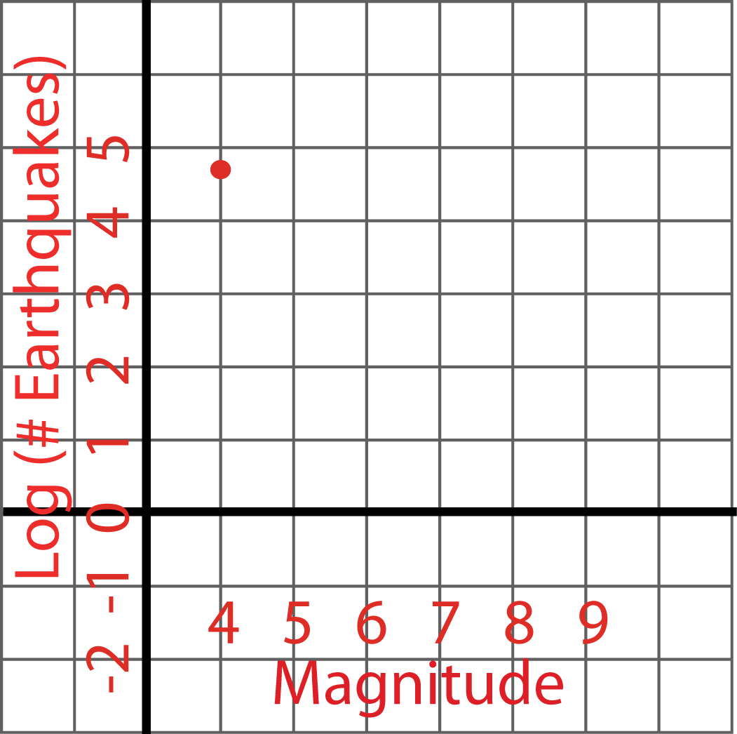
Slope of Earthquake number vs. Frequency for Japan Subduction Zone:

ANSWER KEY FOR JAPAN SUBDUCTION ZONE
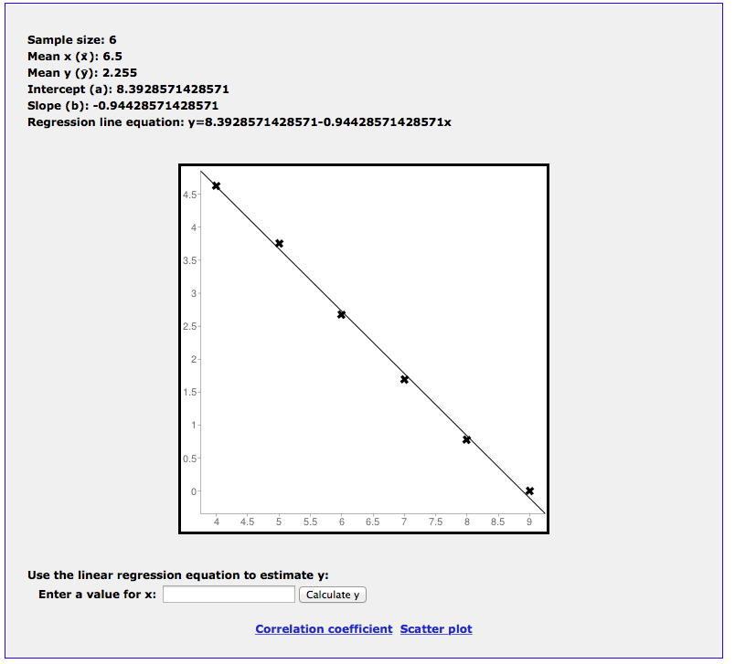

Table 2.: Seismicity of your own region
Magnitude Range (≥ to) | Number of Earthquakes | Log₁₀ of # of Earthquakes

Figure 2.: Graph of frequency-magnitude relationship for the earthquakes in your region
